FSTC 313
FOOD CHEMISTRY LABORATORY

Lab #3: Carbohydrates

- Introduction

Carbohydrates have been used in the history of food as both thickening and gelling agents and are the major energy source both in plants and animals. Plants typically store their energy in the form of large polysaccharides called starch. Starch is composed of linear and highly branched polymeric components called amylose (Am) and amylopectin (Ap) at different ratios depending of the starch source (eg. potato, wheat, tapioca). Amylose, the linear component, is comprised of α (1-4) glucopyransosyl units while amylopectin is linked by both α (1-4) and α (1-6). The α (1-6) linkage introduces kinks to the glucose chain, allowing the amylopectin structure to take on a branched appearance. Both polymeric species play an important and distinctly different role in the gelatinization and retrodegradation process of a starch molecule.
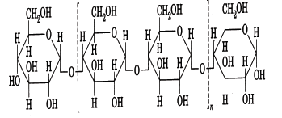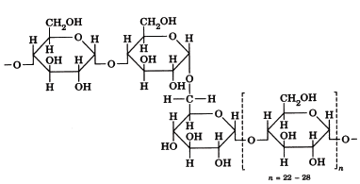
Amylose
Amylopectin

Amylopectin is typically found in the crystalline region of a starch molecule while amylose is thought to be found in the amorphous region of the starch granule. Upon heating the starch granule, amylose (which is not found in the crystalline region) is easily leached out of the starch granule and the starch granule begins to take in water and swell in the crystalline region. The increase in viscosity that is observed is due to the friction of the starch granules that have swelled. The higher the content of amylopectin, the higher the viscosity is upon gelatinization. The gelatinization temperature, or temperature at which maximum viscosity is reached, is dependent on the source of starch. Once cooled, a process known as retrodegradation will occur in the starch slurry. Retrodegradation is simply the re-association of hydrogen-bonds between the amylose molecules that are leached from the starch granule. An increase in amylose content will result in an increase in viscosity at retrodegradation. The food industry capitalizes on the difference in functionality amylose and amylopectin afford to starches. For example, a waxy cornstarch (high in amylopectin) is used in scenarios where high viscosity is needed upon being heated, but retrodegradation not ideal.

Cellulose, a polysaccharide found in the cell wall of a plant and the single most abundant organic polymer, can also alter the viscosity of a food system. Cellulose is composed of β(1-4) linked glucose molecules, making this polysaccharide indigestible to humans who lack the enzyme capable of breaking the β linkage. Cellulose is water insoluble and typically only used in its modified form, carboxymethyl cellulose (CMC). The COO⁻ causes the cellulose strands to “repel” each other, increasing solubility. CMC is highly viscous and very stable, lending its functionality to reduced-fat ice creams and as a protein stabilizer.

Gums such as guar gum and gum Arabic are common in the food industry, and hard to substitute with other ingredients. These gums produce the highest viscosity and offer economical solutions to food companies by providing thickening at very low concentrations. Gum Arabic is a formed from highly branched ß-galactose units. It is water-soluble, produces a low viscosity, and is used to stabilize flavor emulsions as well as inhibit crystallization of sugar. Locust bean gum is used to change the viscosity of a food system. This polysaccharide is composed of a mannose backbone with galacturonide units attached. It is only soluble in hot water and produces a high viscosity once hydrated and at very low concentrations.
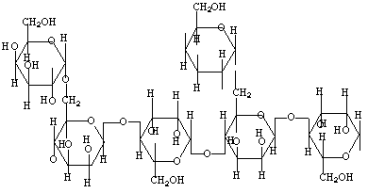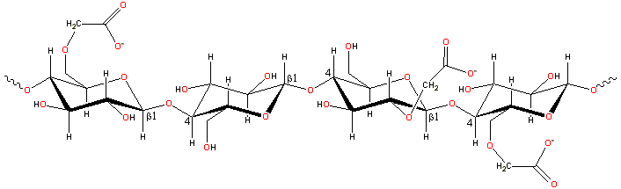
Locust Bean Gum Carboxymethyl Cellulose (CMC)

- Objectives

To investigate the factors that affects the thickness of a cooked starch paste and to compare the usefulness of various starches (i.e. normal, waxy, and modified) as potential viscosity modifiers.

- Materials
Starches: Rice, wheat, potato, etc
Gums: Xanthan, Guar, Locust bean, Arabic, etc
Test tubes, beakers, hot plate, thermometer
Modifiers: sucrose, citric acid, oil, salt, oxidizers, etc

- Methods
Starch Gelatinization, Gelatinization Temperature Range, and Gel Formation
- Weigh equal amounts (~0.25 grams) of different starch types (given in class) in a test tube. Use approximately the same weight and same volume for each starch.
- Add water to fill the tube ~80% full, screw cap, and shake vigorously!! Avoid dry lumps at the bottom.
- Place into a beaker of water and slowly begin to heat the water over 5-8 minutes.
- As it heats, shake/mix/stir the tubes vigorously to mix. Don’t be shy…shake and mix it well and often.
- Constantly record temperature of the water and/or starch slurry (do not use thermometer to stir!)
- Heating the water slowly, things will get interesting in the 60-75°C range (gelatinization)
- Record any observations during the heating process (soluble, insoluble, paste, clarity, gel, color etc.).
- Record the temperature and start a clock when you first see gelatinization (opaque gel), record this temperature.
- Continue heating and record the temperature when the last bit of starch has gelatinized (clear).
- This is the GTR, the temperature range at which it began and completed gelatinization.
- Note the viscosity in the tube by shaking, mixing, or inverting.
- Cool the starches in water and observe any changes in viscosity or gel strength.
- You can also pour or scrap out the gel (once cooled) to physically touch/feel the gel and its strength

Modification of Starch Gelatinization
- Weigh 0.5 to 1 g of starch each into a beaker (follow the matrix given in class). You may try several treatments and compare against a control (just water and starch).
- Add ~25-50 mL water to each beaker (be consistent) plus the following treatment additives:
  - Sucrose
  - vegetable oil
  - citric acid
  - Other additives may be provided in class
- Mix ALL of the ingredients together AT ONCE and mix well.
- Place on a hot plate and SLOWLY heat until gelatinization temperature is reached. This will vary according to modifications so it is important that you record all observations and specific gelatinization temperatures of each modification.
- Do not over-heat the slurry, or you will burn the starch and/or evaporate the water. Keep the water constant in your beaker, even if you have to add a bit more water. Take your time in heating. Stir frequently!!! Watch your water volume. Mix, mix, mix.
- After gelatinization, cool on ice to below 50°C.
- Pour the samples (the exact same amount) onto the line spread test grid.
- Determine viscosity using the line-spread test (allow paste to spread exactly 2 min.).
  - Line-spread test: Use a standard/consistent sample size, dump onto the line-spread circles, allow to spread for 2 mins. Record nearest line on all four sides.

Starch Gelatinization: Water Competition
- Repeat the trials using any of the above modifiers.
- Develop a hypothesis with your lab partner, write this in your lab book, and make predictions about outcomes.
- Vary the order of addition.
- Try mixing in other hydrocolloids (gums).
- Set up experiments where the ingredients are “fighting” for water.
- Vary concentrations, ingredients, heating times, and modifiers
- There is an endless number of combinations.
- Write your observations and notes in your lab book.

- Results
- How does GTR help you as a product developer or food processor? Explain.
- Which starches would be suitable for thickening a sauce or gravy? For a cherry pie? For a cream pie? A soup? Why or why not?
- What effect does the addition of sugar, oil, and acid have on the gelatinization of starch? Why is this important for the food industry? Explain.
- Is there competition for water in complex food systems? How does order of addition impact a food?

Starch and Gum Modification Trials (Combined Groups)
Lab Group # | Modifications
1 | Sucrose = 0, 5 and 10 grams
2 | Oil = 0, 2 and 5mL
3 | Citric Acid = 0, 3 and 6 grams
4 | Sucrose+Citric Acid = 0+0, 5+3 and 10+3 grams
5 | Oil+Citric Acid = 0+0, 2+2 and 5+2grams
Others | We may have some additional treatments you can try

